B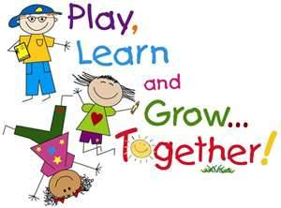
Entry Point:
Teddy Bear’s Picnic

Literacy & Communication
- Traditional Stories. Goldilocks & 3 Bears, Three Little Pigs, Gingerbread man.
- Non-fiction books on ourselves, bodies & senses. Colour Monster story~ emotions
- Story telling, oracy skills & vocab acquisition
- Guided whole class reading
- Nursery Rhymes
- Unlocking Letters & Sounds-Phonics
- Roleplay, café, baby clinic
- Labels, lists & captions
- Fine motor skills & letter formation.
- Writing own name. Drawing club
- Dough disco/Finger gym.

Number, Numerical patterns

- Have a deep understanding of numbers to 10
- Subitise (recognise quantities without counting) up to 5
- Recall number bonds up to 5
- Verbally count beyond 20
- Compare quantities up to 10
- Explore & represent patterns within numbers up to 10
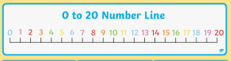
Understanding the World: Natural World
- Identify, name, draw & label basic parts of the human body.
- Explore 5 senses outdoors : Feely bags with natural objects smelling game, flowers & herbs. taste quiz.
- Eating & keeping healthy
- Explore the natural world, making observations
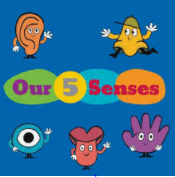
What you can do to support your child’s learning in this area:
- Look at family photos and share memories.
- Practise phonics flashcards
- Share a book everyday
- Talk about your favourite fairy tales and share them.
- Use apps like Pirate phonics, maths bingo, writing wizard,
- Look for numbers at home & when out & about. Lots of counting!
- Independence when dressing, eating, toileting.

Technology/ Computing
- Gather info about ourselves from a variety of sources. Use books, internet, computers, ipads, dvd’s. Age approriate learning apps. E-Safety
- E-safety
- RM maths & Mathletics

Prussia Cove Me, Myself and I What makes me unique?
Useful links:
- www.teachyoumonstertoread.com/
- www.teachingyourghild.org.uk/
- www.bbc.co.uk/schools/scienceclips
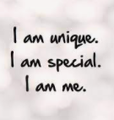

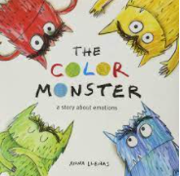
Expressive Arts & Design
- Self- portraits.
- Food Tech
- Design a new chair for Baby Bear
- Harvest Festival art work , vegetable printing,
- Firework printing
- Poppy collage
- Christmas art.
- Singing familiar songs heads, shoulders, knees & toes. Charanga
- Exploring sound made by a variety of instruments. Look at rhythm and beat.
- Talk about pitch. High/low sounds. Harvest/Christmas songs
Understanding the World:
Past & Present, People, Culture & Communities
- Our own personal timeline of changes since birth. Once there were Giants book
- Toys we have played with ~ changes
- Story of Guy Fawkes & Gunpowder Plot/Remembrance Day
- Local environment, physical features observed on welly walks. Simple maps.
- Mapping classroom, Mini me’s route to school, local area. Aerial photos & birds eye view. Google maps.
- Celebrating diversity, children around the world

Physical Development
- Outdoor PE Stability & locomotion.
- Ball, beanbag throwing/catching.
- Fine/gross motor skill activities: Finger gym/Dough disco
- Outdoor play equipment, obstacles
- Daily Mile
- Welly walks

Understanding the World: People, Culture & Communities
- Celebrations in Christianity and Hinduism. Harvest Festival & Christmas. What makes me special?
- Celebrating diversity,
- Bible Stories.

PSED
- Keeping safe and being healthy
- Jigsaw: Being me in my world
- Settling in to school
- Golden Rules.
- Learning, playing together.
- Making relationships
- Explore feelings and emotions.
TRIPS/EXPERIENCES:
Picnic preparations. Welly walks. Forest School activities. Outcome: Presenting an autobiography This is my life

