PARENT GUIDE
Goal
When it comes to times tables, speed AND accuracy are important – the more facts your child remembers, the easier it is for them to do harder calculations.
Times Table Rock Stars is a fun and challenging programme designed to help students master the times tables.
To be a Times Table Rock Star children need to answer any multiplication fact up to 12×12 in less than 3 seconds. The goal is for all participating rockers to be Times Table Rock Stars.
World famous rock musicians are the best at what they do because they've spent hours practising guitar chords, writing music or playing on the drums. It's just the same with times tables – all Times Table Rock Stars need to practise and practise and practise.
It's absolutely essential that your child does a little bit of times table practice every night. In my experience, short bursts of practise on a daily basis are more effective than spending hours once a week.
And this is where you come in. For your child to be fully motivated and for them to get the best out of the practice, they need your help. Without your praise and your reminders, without you sitting down next to them or checking their work, practising times tables will not feel important to your child.
We hope that children become more confident overtime and that they master their times tables in order to use these in other areas of the curriculum.

Logging in to
- Type ttrockstars.com into your browser’s address bar.
- Log in. Your child’s TTrockstars username and password are the same as their Mathletics details (usually at the back of their planners).
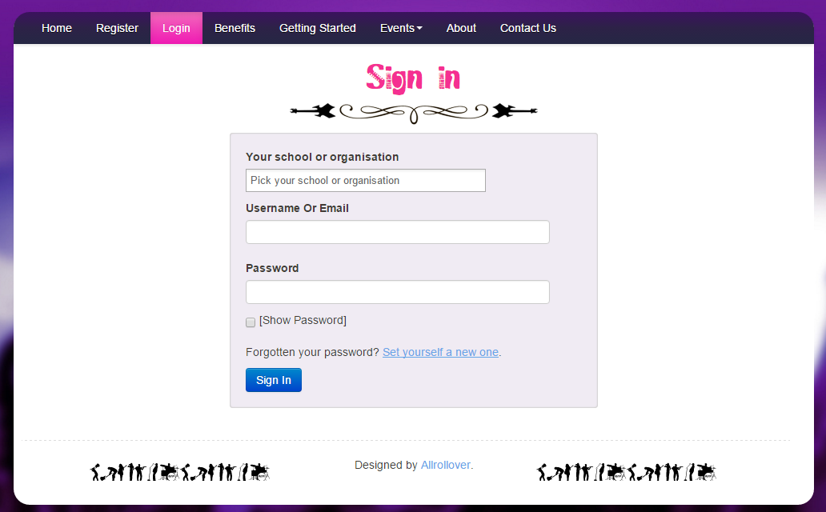
Password goes here
Username goes here
School goes here

- Play!
There are 4 different game modes.
Rock names
When children initially logged in, they would have chosen their one and only ‘Rock name’ which is what they will always be referred to on TTRockstars which adds to the exciting element of the games. Once chosen, these cannot be changed.
Avatars
Children are able to create a characterised profile with funky rock accessories which when they have achieved ‘coins’, are able to buy rarer, more exciting backgrounds, guitars, clothes etc. This really adds to the exciting rock star image that children will aspire to on TTRockstars.
Game Modes
Single Player
Garage - the questions will only come from the times tables the teacher has set for the week. As pupils start to answer questions, TT Rock Stars works out which facts they take longer on and will give them more of these questions to answer. The Garage is best for getting quicker at a few facts. Players get 10 coins per question.
Studio - the questions in the Studio can be anything from 2x2 up to 12x12.
TT Rock Stars calculates each the mean speed from their last 10 games in the Studio and translates into a Rock Status:
Under 1 second per question to become a Rock God
Under 2 seconds per question to become a Rock Legend
Under 3 seconds per question to become a Rock Star
(See below for more information)
The children earn 1 coin per question and the Studio is the place for them to set their best time across all the tables.
Multiplayer
Rock Arena - The Arena allows players to compete against all other members of their Band (their Bandmates would need to join the same game in order to compete together).
A new Arena game starts every 15 seconds and once the clock starts they race to answer more questions than the others. In the Arena, questions will only come from the times tables the teacher has set for the week, similar to the Garage. They earn 1 coin per correct answer.
Rock Festival - The Rock Festival games are open to players from around the world. Like the Arena, there is no limit to the number of players who can join a game; however, unlike the Arena, questions are selected at random from 2x2 to 12x12.
Pupils might choose the Rock Festival if they were playing at home (and therefore couldn't easily synchronise playing against a classmate) or wanted to compete against others not in their Band. They earn 1 coin per correct answer.

Stats
If you click on Me>My Stats, a heat map like the one below will load. It shows how successful your child is at each of the facts meaning that over time, these should be the tables they focus on individually to help achieve their St Hilary times table cards.
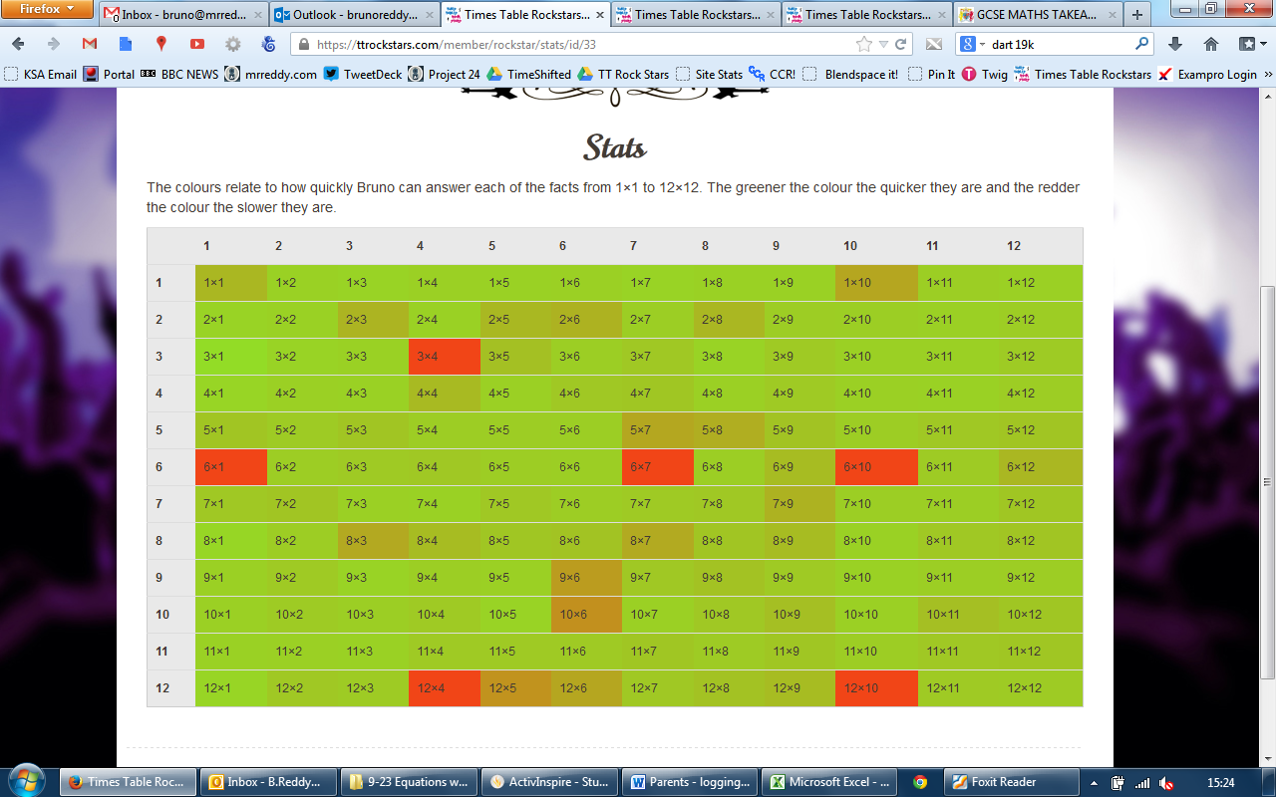
Rock Status
It’s helpful to understand that the quicker your child can answer a times tables question, the higher their Rock Status. Use this list as a guide to help your child work out their Rock Status:

≤ 1 sec/qu = Rock God  ≤ 2 secs/qu = Rock Legend  ≤ 3 secs/qu = Rock Star  ≤ 4 sec = Headliner  ≤ 5 secs/qu = Support Act  ≤ 6 secs/qu = Breakthrough Artist | ≤ 7 secs/qu = Unsigned Act  ≤ 8 secs/qu = Gigger  ≤ 9 secs/qu = Busker  ≤ 10 secs/qu = Garage Rocker  > 10 secs/qu = Wannabe
Questions, Problems, Suggestions and Complaints
Contact Ashley Larter on email: ashleylarter@st-hilary.cornwall.sch.uk if…
- You have username or password issues
- Something isn’t working or you’re not sure how it works
- You have something nice to say about ttrockstars.com
Contact your child’s teacher if you have any other questions also.
Enjoy!

