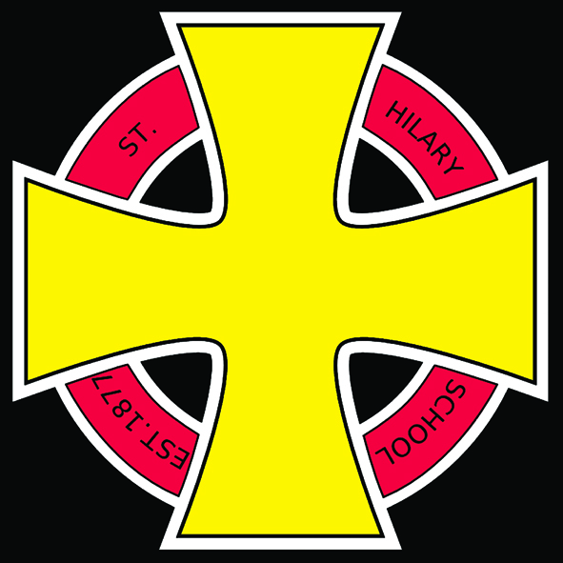 St Hilary After School Club Fees Policy

Rationale
This policy outlines payment conditions, modes of payment, procedure for late payments, invoice disputes, cancellations, forced closures and payment difficulties.

Payment conditions
After School Club fees
Payment will be split over two sessions- 3.30pm to 4.30pm and 4.30pm to 5.30pm.
Each session costing £3.60 per child.

Fees will be reviewed for the beginning of each academic year. Parents will be informed of any changes in writing.

Late collection fees
If you are late collecting a child, you will be charged a late collection fee as follows:
£5 per child for collection between 5.30 pm and 6:00 pm.

If collection takes place after 4.30pm, when a child is booked in for the first session only, then the full cost for the second session will be charged.

Invoices and payment terms
Invoices will be prepared at the beginning of each month, based on the bookings made for that month.

All payments must be received within 30 days of the date of the invoice. In cases where fees are not paid within 30 days a reminder letter will be sent by post asking for a payment to be made within one week of receipt of the letter. If payment is still not forthcoming then further bookings will be suspended.

Any queries regarding invoices should be addressed to the St Hilary After School Club Leader.

Booking cancellations
Booked sessions may be cancelled with one weeks’ notice.
Any session cancelled less than a week in advance will be charged at the normal full rate.
Booked sessions, cancelled due to illness, will be charged at full rate for the first day and 50% for each following day. In the case of extended illness over one week no fees will be charged.
Cancelled sessions will be offered to other children.
If your child is away from school on a school residential trip there will be no charge.

Payment difficulties
If you experience problems in meeting the payments, you must contact the St Hilary After School Club Leader to avoid your child’s place being withdrawn. You will be required to send a letter outlining the problems. The matter will be dealt with confidentially.
In this eventuality and upon receipt of such a letter, the leader, and Headteacher of St
Hilary will meet to discuss the case and formulate an appropriate response. Should St Hilary consider the claim to be valid, support may be provided which could involve deferred payment or payment over a longer period of time. Any such decisions will be made on a case-by-case basis and you should not have any expectations in terms of the response you might receive. We may also, with your consent, be able to seek professional and/or financial support to help you.

Mode of payment
Payment to settle your invoices to be made using Parentpay our online payment system.

You can also pay with electronic childcare vouchers
If your employer offers a childcare voucher scheme, you may be able to use these towards
payment for your booking. These schemes are exempt from tax and National Insurance. You may wish to approach your employer for more information.

We are currently registered for ‘Edenred’. If you wish to use any other schemes please contact us so that we can register to allow this to happen.

When making your payment online, please reference the invoice number and the name of
the child(ren) if possible.

Paying with paper childcare vouchers
Please consider switching to electronic vouchers if at all possible, as these are much quicker to process.
Put your vouchers in an envelope together with your invoice number and the name of the child(ren).
Address the envelope to St Hilary Out of School Club Leader ‘Fees’.

Invoice Disputes
Should you not agree with the amount on the invoice, please speak in the first instance to the Leader. If you do not feel your query has been addressed you may send a dispute letter to the St Hilary After School Club Leader, with a copy of the invoice, outlining the disputed amount and the reason for the dispute. Any such dispute letter must be received at the latest 14 days after the invoice date to be considered. If no dispute letter is received within this period, the invoice is deemed to be accepted, and liable for payment in full.
On receipt of such a dispute letter, the St Hilary After School Club Leader will investigate the
situation and provide a prompt response, including supporting information as appropriate.
In the eventuality that the invoice is confirmed to be incorrect, a revised invoice will be sent and the same conditions of payment will apply.

Forced closure of the St Hilary After School Club
In some extreme circumstances, St Hilary After School Club may be forced to close unexpectedly at short notice.
If the club is closed due to closure of St Hilary School, no charge will be made. If the club closes early for any reason, the appropriate charges will be made, at the discretion of the committee. In the event that you are unable to collect the child (children) or if we are unable to reach you to notify you of the closure, then full charges will be made.
Please ensure that the contact details we have for you are up-to-date.
We do not want to be in a situation where we cannot contact you.

FUNZONE NUMBER: 07789 665 659

Date of policy: 7th December 2011
Date agreed by the Academy Trust:

