
Perran Class Spellings Autumn 1: Go for Gold!
Your teacher will tell you your spelling target depending on your confidence and skill in Spelling - you are always welcome to try to exceed your target though! ☺
Everyone will learn the Bronze words each week. Some of you will be expected to learn the Silver and the Gold words too.
Have a go at learning the words every night for a few minutes. Spelling quiz on a Friday!
Week 1 | Week 2 | Week 3 | Week 4 | Week 5
sh | ch | th | ai | ee
BRONZE  must learn | BRONZE  must learn | BRONZE  must learn | BRONZE  must learn | BRONZE  must learn
ship | chop | that | snail | see
shed | chin | this | rain | week
shell | chip | then | wait | deep
fish | rich | them | tail | feet
cash | much | they | pain | peel
SILVER  should learn | SILVER  should learn | SILVER  should learn | SILVER  should learn | SILVER  should learn
the | said | is | your | be
a | says | his | they | he
do | are | has | no | me
today | were | I | go | she
of | was | you | so | we
GOLD  could learn | GOLD  could learn | GOLD  could learn | GOLD  could learn | GOLD  could learn
shower | chicken | there | trainer | sleep
shadow | church | with | painter | wheel


Use your eyes
- Look at the word. Is it short? Is it long? What else do you notice when you look at it?
- Can you see any small words inside your word?
- Take a picture of the word in your mind. Shut your eyes. Can you see it?
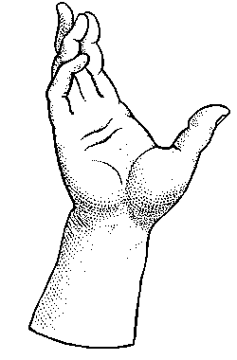
- Write the tricky part of the word in a different colour.

Use your hand
- Write the word in the air.
- Write the word in your best joined handwriting.
- Write the word again with your eyes shut.
- Write the consonants and vowels in different colours.
- Cut out letters from newspaper to make your spellings


Use your brain
- What does this word mean? Look it up in the dictionary if you’re not sure.
- Put it in a sentence.
- Can you spell bits of this word already?
- Can you write any words that rhyme with this one?
- Do you know other words with the same pattern?
- Can you think of a phrase to help you remember it? For example: could – oh you lucky duck
- Learn the meanings of the different word parts, e.g. pre- means before, sub- means under

Use your ears
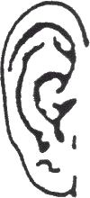
- Say the word out loud. Spell it out loud.
- Clap the syllables: hos-pit-al
- Say the word in a silly or exaggerated way
e.g. Wed-nes-day

Use your friend
- Show your word list to your friend. Give some clues about one word. Can they guess the word?
- Ask your friend to ‘write’ one of your words on your back with their finger – can you feel and imagine the letters?
- Sort your words e.g. alphabetically or by length or the number of syllables. Can your friend see how you have sorted them?
- Ask your friend to ‘test’ you when you know all your words.
- Make a wordsearch and swap it with a friend.
- Make flashcards of your spellings and play ‘snap’
- Write one letter each – start with 10 points each, and lose a point every time you can’t think of the next letter – who will keep their points

